**DS LAB ASSIGNMENT 3**

**NAME-FORAM GANDHI**

**ROLL NO.-F 32**

1. Create a 2D Array of numbers.

I. Perform addition of two matrix.

II. Perform subtraction of two matrix.

III. Perform multiplication of two matrix.

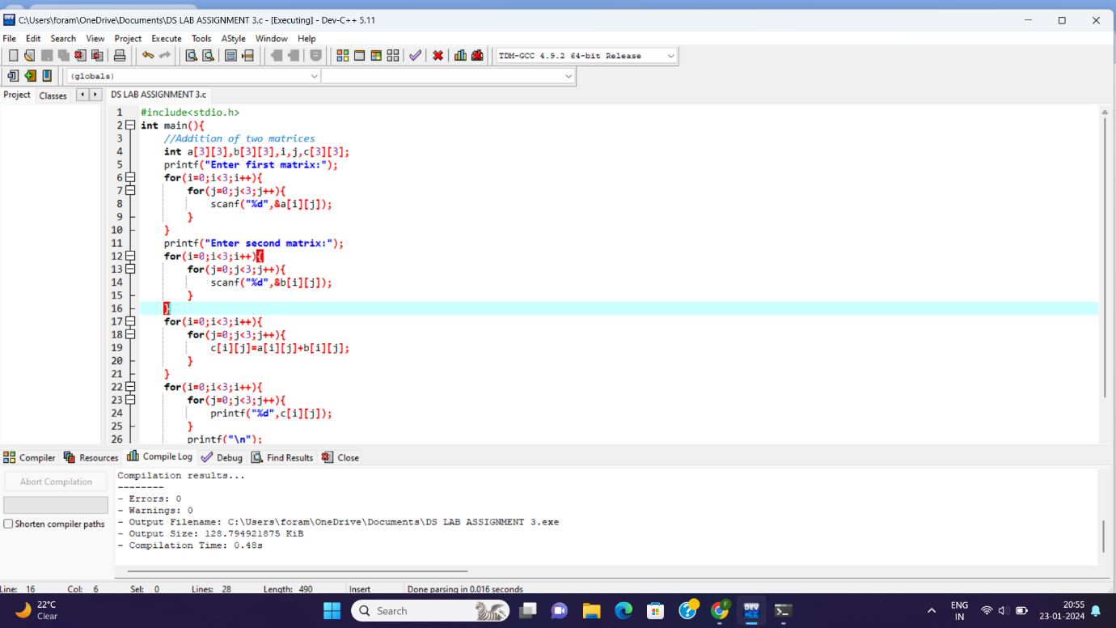

2. Create array of pointers for string of city name. Display the list before and after deleting n- th name from the list.

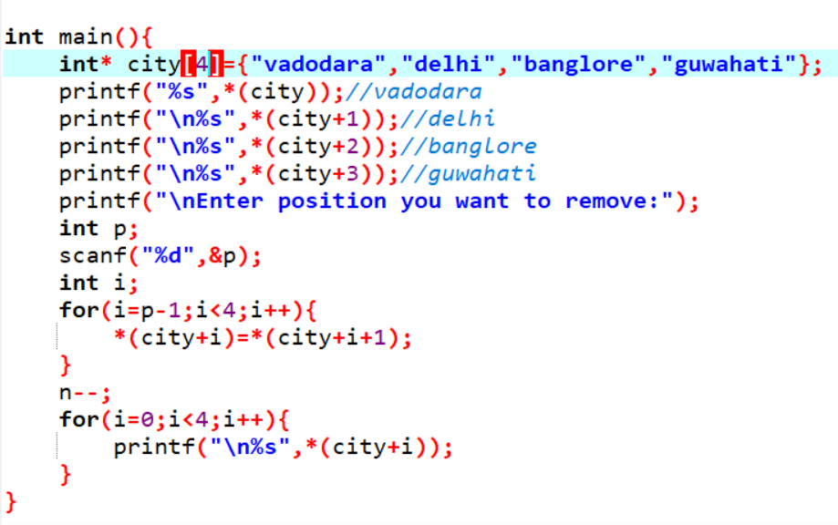

3. Create dynamic list of N cities of dynamic name. Display the list before and after deleting n th city name from the list.

